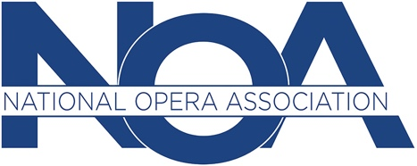

65th ANNUAL NATIONAL CONFERENCE
Opera Rocks!
The Hilton Cleveland, Cleveland, OH
January 8-11, 2020

*Deadline for submission of session proposals: June 1, 2019 11:59PM (EST)
Submit Proposal Form by e-mail to:
Lisa Dawson, Vice President of Conferences, lfdawson64@gmail.com

SESSION PROPOSAL GUIDELINES (carefully read, sign and date below)

The National Opera Association is a volunteer organization. Attendees and presenters are responsible for all meals, travel, housing, and related expenses.

Submitted proposals are being accepted on a wide variety of topics including, but not limited to, opera education, pedagogy, performance practice, production, history, outreach, composition, and other opera-related areas.

If a session proposal is accepted for presentation at the convention, the presenter and all participants must pay the registration fee for the convention, with the exception of invited guest presenters or clinicians.

All session proposal forms must be submitted with a bio (150 word max) of the presenter and all participating panelists for the session to be considered for approval.

Requirements for set-ups must be included in the proposal form, including human resources (singers and pianists), logistical (tables, lectern, chairs) and technical (PowerPoint, screen, microphones, etc.). Any changes to an approved set-up must be submitted to the Vice President of Conferences by October 31, 2019.

Plenary sessions will be 75 minutes. All other presentations will be 50 minutes. Q&A portions of any presentation need to be included in the timeframe. A moderator will be assigned to ensure that all sessions will end on time. This allows 10 minutes to break down and set-up the next session.

The presenter(s) agrees to allow an audio or video recording to be made of the session, which will be available for purchase by conference attendees for educational purposes. Portions may also be made available on the NOA website.

The presenter(s) agrees to allow photos to be taken during the session which will be used on the NOA website and possibly in other printed NOA publications.

By submitting this proposal form to the National Opera Association, I acknowledge that I have read all of these Guidelines and agree to all the terms therein.

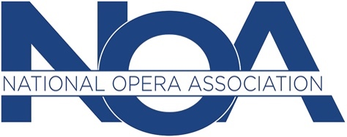

SESSION PROPOSAL FORM

65th ANNUAL NATIONAL CONFERENCE
Opera Rocks!
The Hilton Cleveland, Cleveland, OH
January 8-11, 2020

Due by June 1, 2019, 11:59 PM (EST)

Primary Presenter’s Name (as you want it to appear in all materials):

Email:

Phone number:

Additional Presenter’s Name(s) or Co-Presenter(s) (please specify):

Title of Session:

Description/Abstract of Session (250 word max):

Description for Program Book (100 word max):

Intended Audience:

Description of logistical set-up for the session (placement of chairs, tables, lectern, etc…):

Do you need a piano? YES NO
Do you need pianist? YES NO
Number of pianists/singers requested for the session: ______
List any specific voice types required: ___________________
Describe how repertoire will be chosen/assigned, if applicable: ______________________ ____________________________________________________________________________
____________________________________________________________________________
Is an undergraduate or graduate student preferred? _______________________________

Description of technology needs for the session:

NOA can provide the following audio-visual requirements. Please check all that you will need.
Any other AV needs will be the responsibility of the presenter.

□2 projectors
□1 large projection screen
□1 small tabletop projection screen
□1 8-channel mixer with two powered speakers
□1 4-channel mixer with two speakers
□1 wireless handheld microphone
□1 lavaliere microphone
□6 corded microphones
□4 tabletop mic stands
□1 DVD player

□1 CD player
□1 set of computer speakers
□I music stand

IMPORTANT:

Presenters should not rely on internet connection for streaming audio or video during presentations.

Presenters must provide their own laptop/iPad, adapters and extension cords for their devices.

Describe any other special requirements or considerations about your session:

Provide bio(s) (150 word max) for each presenter here:

____________________________________
Name of Person completing session proposal form if different from primary presenter:

____________________________ _____________________________
Email: Phone:

TO BE COMPLETED BY THE CONFERENCE COMMITTEE

_____APPROVED: ______NOT APPROVED:

_____PLENARY SESSION (75 MIN) _____REGULAR SESSION (50 MIN):

COMMENTS:

ASSIGNMENT:
DATE:
TIME:
ROOM:

