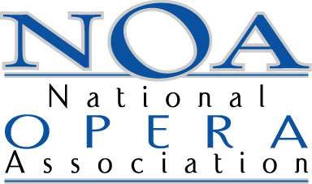
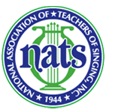
National Opera Association 61stAnnual Convention& NATS Winter Workshop
Masterclass participant application
Submission deadline: Midnight, December 4, 2015
Email with current resume to: NOAmasterclass2016@gmail.com
Name Cell Phone
Address City State
Email Address Voice Type
Video recording information
YouTube/Vimeo, etc. link
Repertoire
Will your pianist be at the convention?
Name and phone number of pianist
Are you and your pianist applying as a team for either the Julia Faulkner/Margo Garret Opera Aria Masterclass (Sat. Jan 9) or the David Duncan Great American Songbook Masterclass (Fri. Jan 8)? If “Yes” indicate which, or both: ________________________________________
Note: more advanced singer/pianist teams for Faulkner/Garrett class are desired. Any level of background is appropriate for Duncan class.

Convention Masterclass Participant registration information:
Current Students, any level:
If you plan on attending only the day on which you sing, the registration is the student day rate: $75. You are free to attend all convention activities that day, in addition to the masterclass on which you are singing.
If you plan on attending more than one day of the convention, registration is the student convention rate: $125. This includes ALL convention activities: opening luncheon, the GALA banquet and more. Please check the appropriate registration choice:
Single day Full Convention _____
Non-Student Adults:
If you will attend only on the day you sing, you must register for the day rate as either a NATS or NOA member or non-member via one of their websites.
If you will attend the full Convention/Workshop, you will also register via the NATS or NOA website. This includes ALL convention activities: opening luncheon, the GALA banquet and more. Please let us know what your choice will be by checking the appropriate line below.
Single day Full Convention _____

